# Selection statements

Game.cs

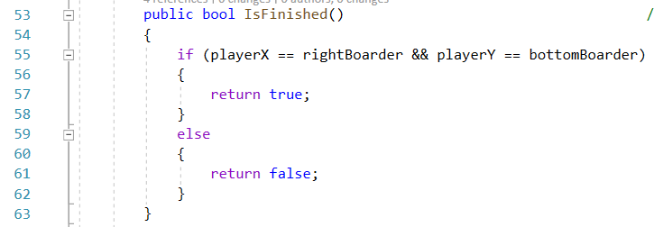

# Iteration statements

Game.cs

# Arrays

Level.cs

# Classes



# 8. Readonly

LevelForm Form1

# 15. Interfaces

Ilevel

# 24. static

LevelDesigner Program.cs

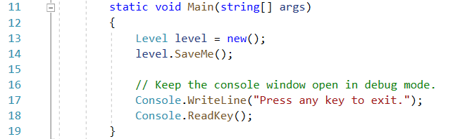

# 27. Enumeration types

Part

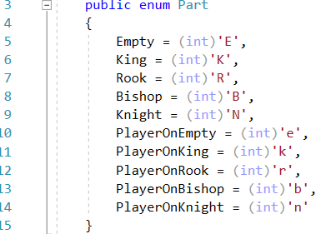

# 29. Using statement

Level

